|  |
| --- |
| **PART TWO Information Technology Technical Question 3 mins** |

In this part of the exam, you will talk about **IT Lessons at School.** The following ideas will help you.

* What programming languages do you learn? Which do you prefer and why?
* How often do you have programming lessons?
* Have you learnt programming since the 1st year?
* What about computer hardware or building a computer?
* What do you need to do for your Maturita exam in IT?
* What are/ were your favourite lessons at school?

**2A**

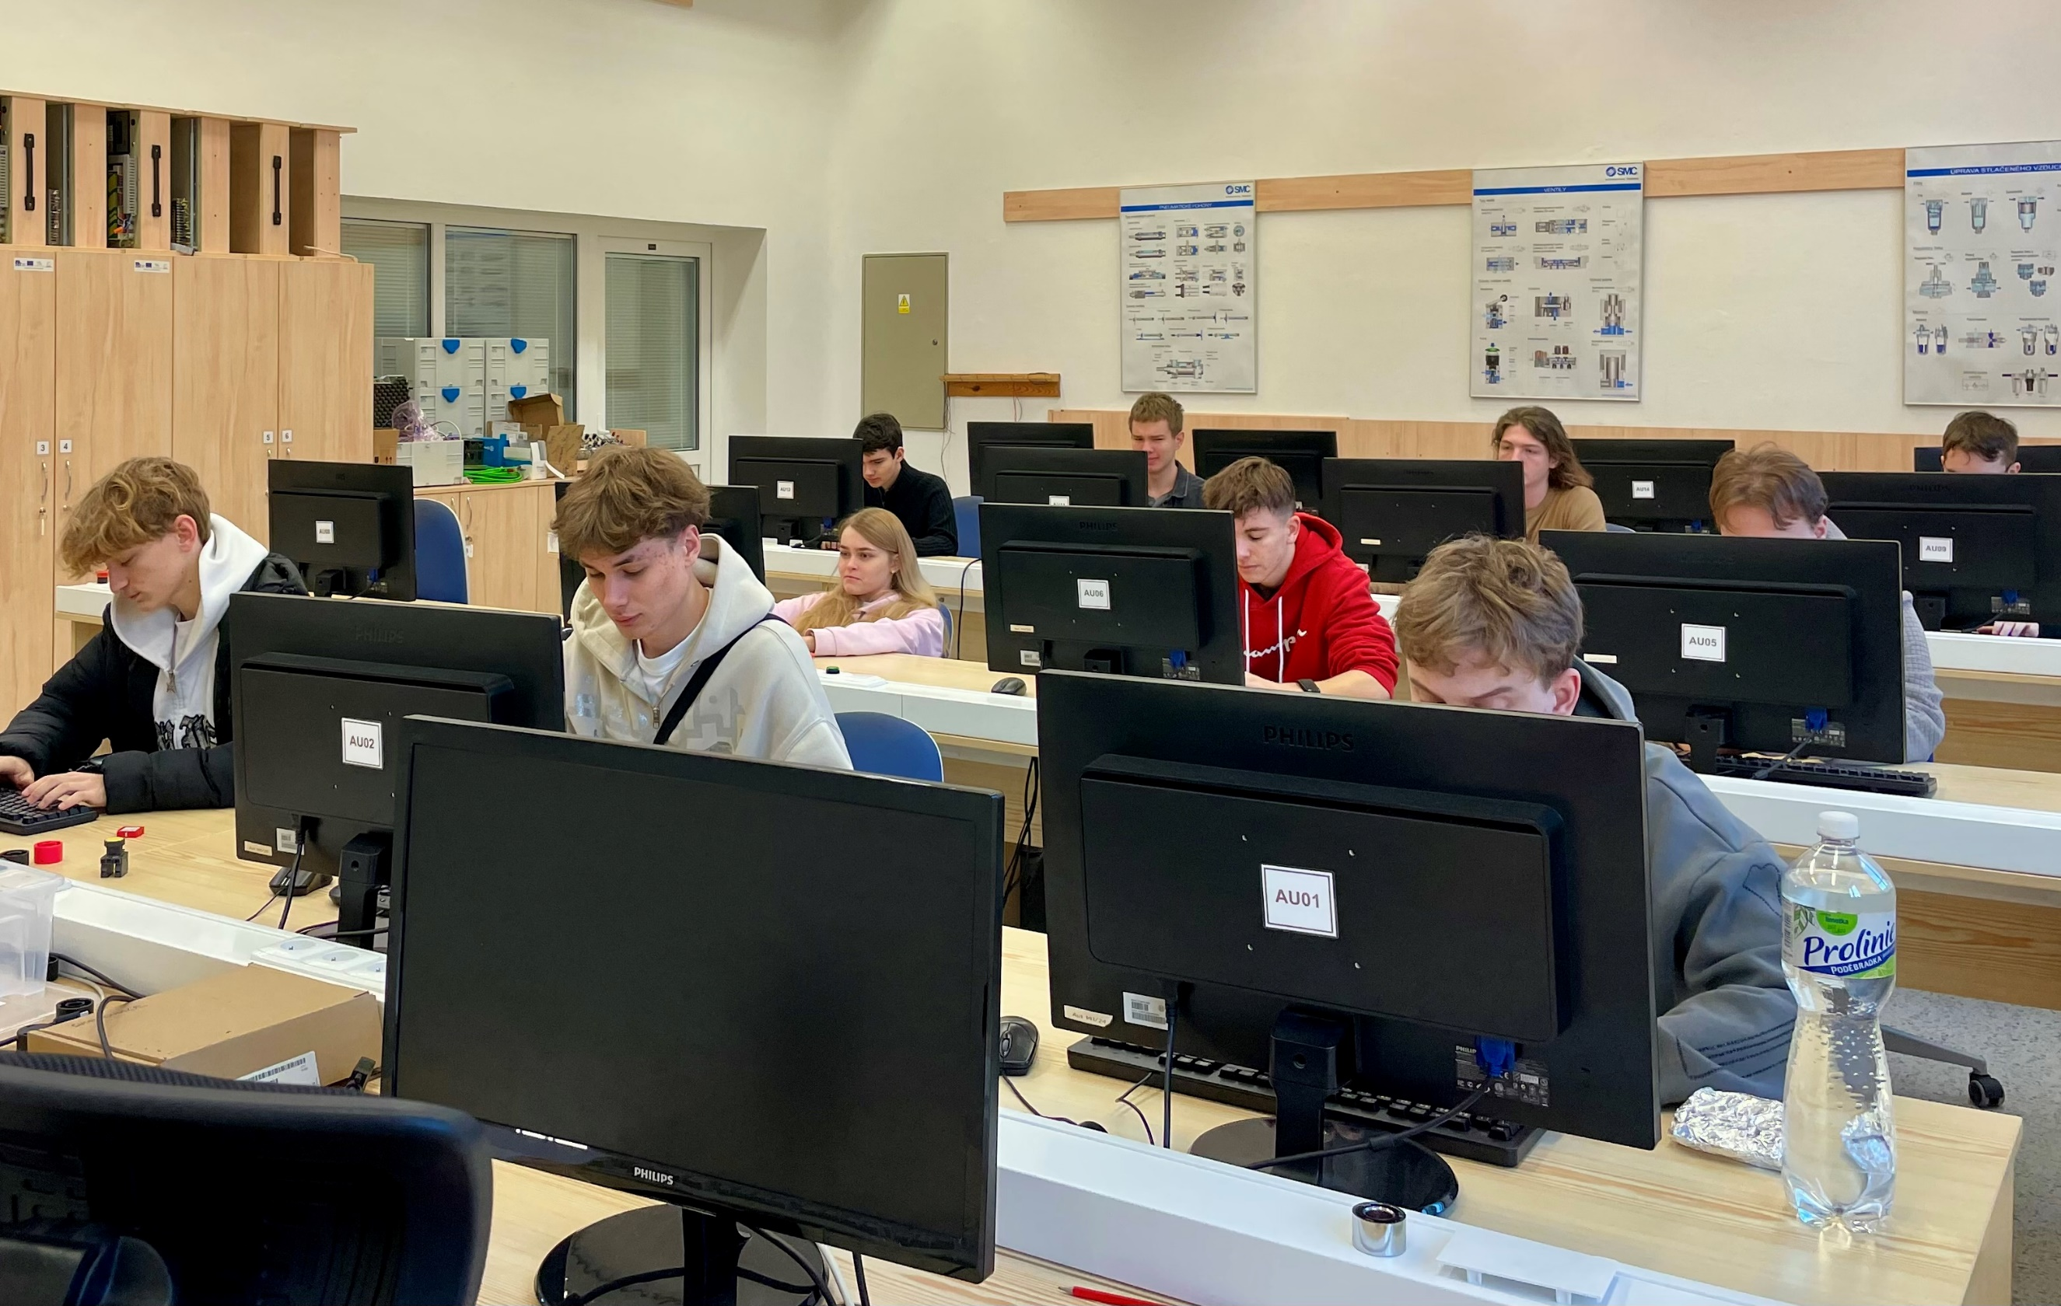

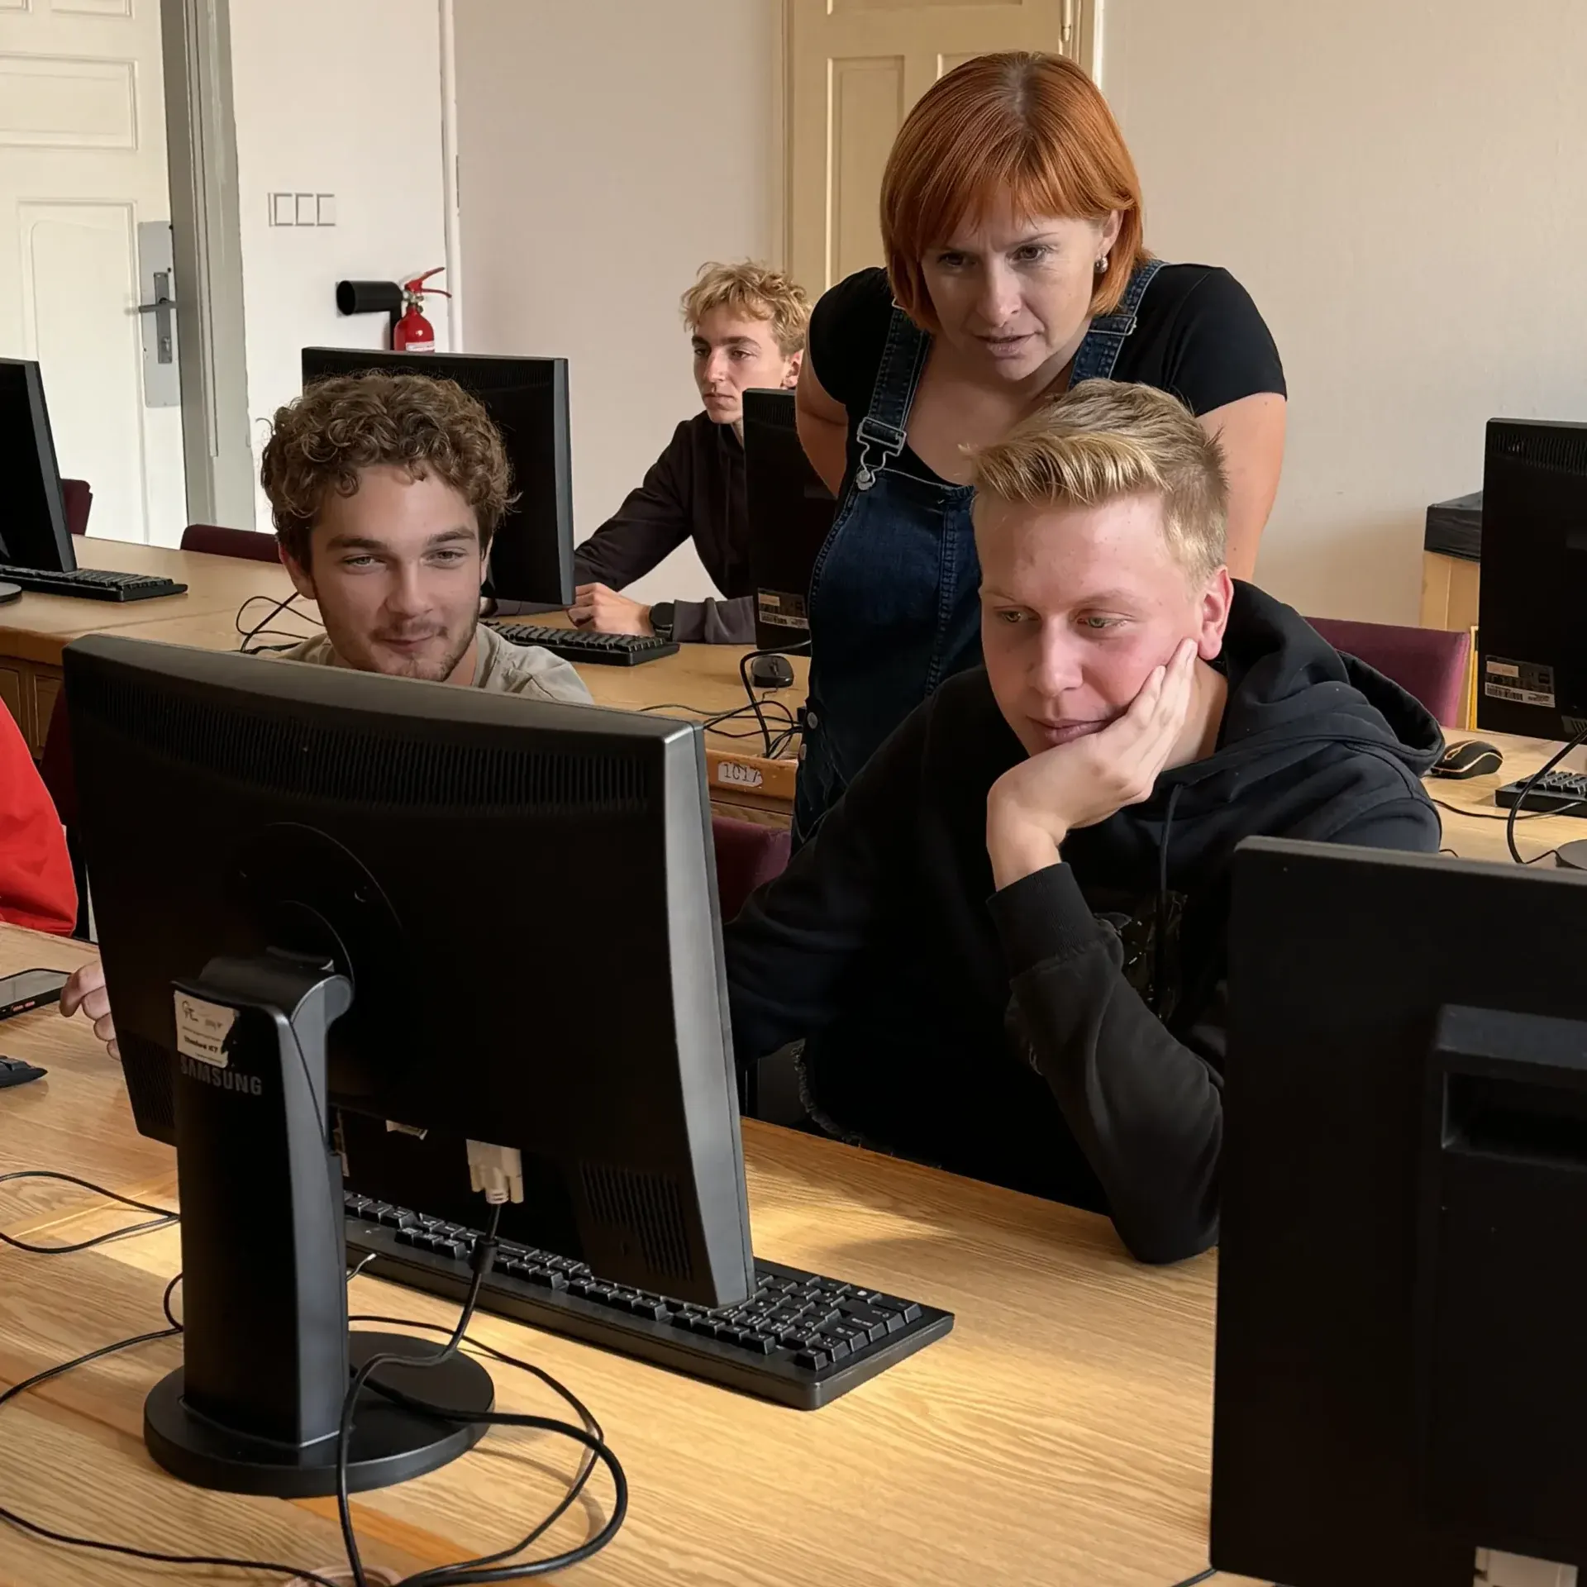

**2B**

|  |
| --- |
| **PART TWO Information Technology Technical Question 3 mins** |

In this part of the exam, you will talk about **IT Lessons at School.** The following ideas will help you.

* What programming languages do you learn? Which do you prefer and why?

HTML, PHP, Java, C#

* How often do you have programming lessons?

4th = Programming lessons 4 days per week (8 hours) 5 x Java 3 x PHP. Programming theory

2nd and 4th = HTML

Different teachers for:

* Same teacher Java/ PHP
* Office Apps
* Operating systems
* Computer networking
* Hardware Theory = 2nd year
* Have you learnt programming since the 1st year?

No programming 1st year – applications, basics

Programming 2nd to 4th year

* What about computer hardware or building a computer?

3rd year = Practical hardware/ built a computer.

* What do you need to do for your Maturita exam in IT?

**Maturita:** Practical 3 parts/ tasks to complete in 6 hours. E.g. Programming, PHP/ Data Bases and office applications

50 questions to choose from in Oral exam = pick a number

* What are/ were your favourite lessons at school?





**2B**

**2A**